Regression.US_FullFlow_15-Nov-2017 07-19-54 PM.png

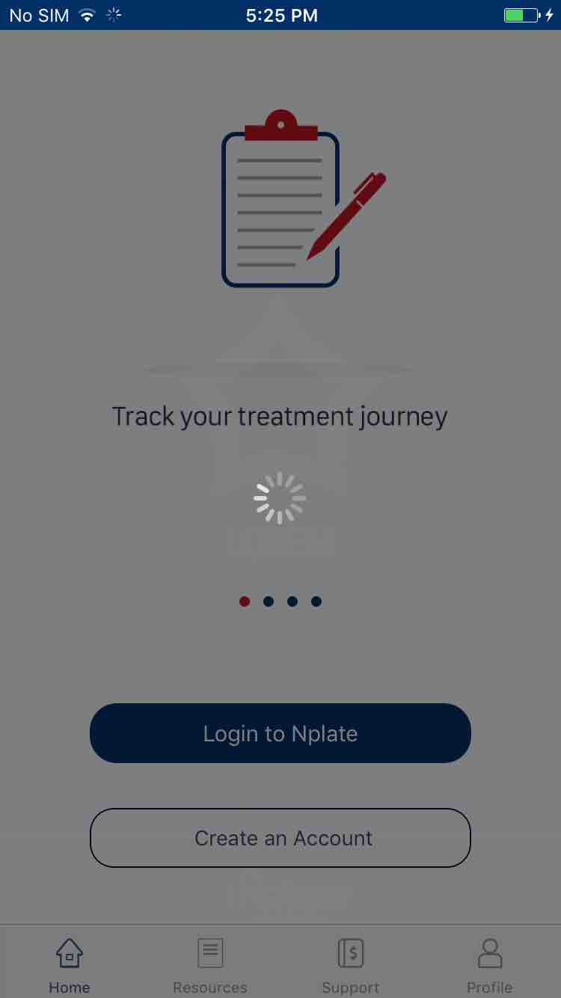

Regression.US_FullFlow_15-Nov-2017 07-19-59 PM.png

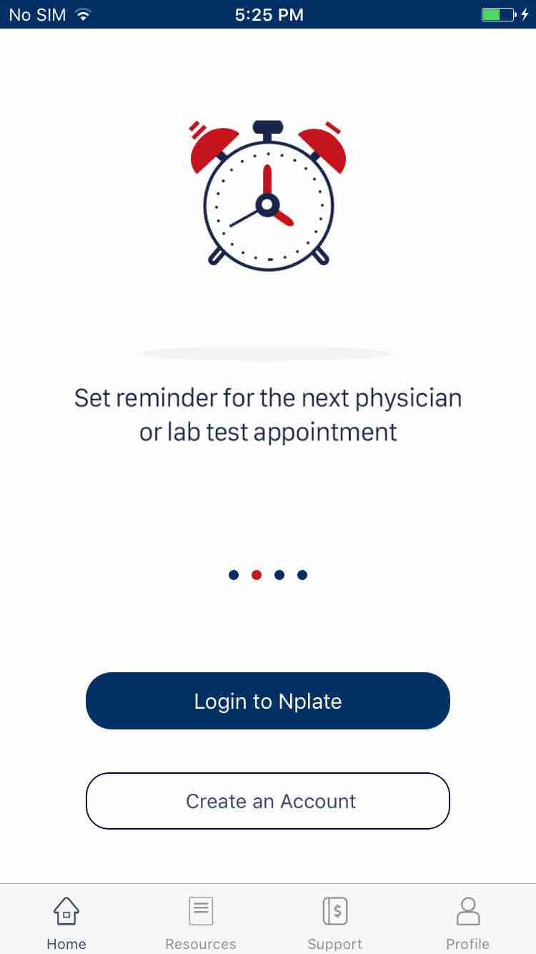

Regression.US_FullFlow_15-Nov-2017_07-20-21_PM.png

